3.1 Architectural objectives
The architecture must support:
- Multiple users operating their own Windows computers.
- A shared backend that authenticates requests and coordinates tasks.
- Safe execution of permitted operations on the correct computer.
- Local-first AI without a mandatory paid inference API.
- Persistent task state and user-specific memory.
- Concurrent requests, disconnections and recoverable failures.
- Clear component boundaries that enable independent testing and future extension.
The architecture should be as simple as possible for a three-person team while preserving the boundaries required for security and correctness.

3.2 Proposed logical architecture
Client layer
Terminal CLI · Authentication · User commands · Progress display

API and application layer
Identity & Access
Request Handling
Policy Engine
Task Orchestrator
AI services
Model adapter, planning, context retrieval and structured tool proposals.
Persistence
PostgreSQL, task records, task steps, memory, approvals and audit events.

Per-device execution layer
Device Registry & Routing
Windows Bridge
Restricted filesystem and application tools on each registered Windows computer.
Logical components, not a finalized physical deployment. Arrows represent conceptual communication, not all required network connections.

3.3 Component responsibilities
Component | Responsibility | Must not do
CLI client | Submit requests, display task status, collect user decisions | Make authorization decisions on behalf of the server
FastAPI layer | Validate requests, authenticate callers, expose API contracts | Execute arbitrary model-generated code
Identity and access service | Resolve users, devices and permissions | Trust a user-supplied device ID without authorization
Agent/planning service | Interpret requests and propose structured plans | Grant permissions or declare unverified success
Policy engine | Validate tool, user, device and approval requirements | Delegate authorization to the model
Task orchestrator | Manage task states, step ordering, cancellation and recovery | Lose durable state when a process restarts
Model adapter | Provide a stable interface to the selected model runtime | Couple business logic to one model's response format
Memory service | Retrieve and manage authorized context | Expose another user's memories
PostgreSQL repository layer | Persist and query application state | Bypass ownership rules in application operations
Device registry and router | Resolve an authorized target device and connection status | Silently redirect work to a different computer
Windows bridge | Execute registered, permitted local operations | Accept unrestricted shell commands or arbitrary operations
Audit and diagnostics | Record relevant state transitions and outcomes | Store secrets or unnecessary private content

3.4 Request execution sequence
The following sequence describes the proposed happy path. Failure and retry paths will be documented separately.
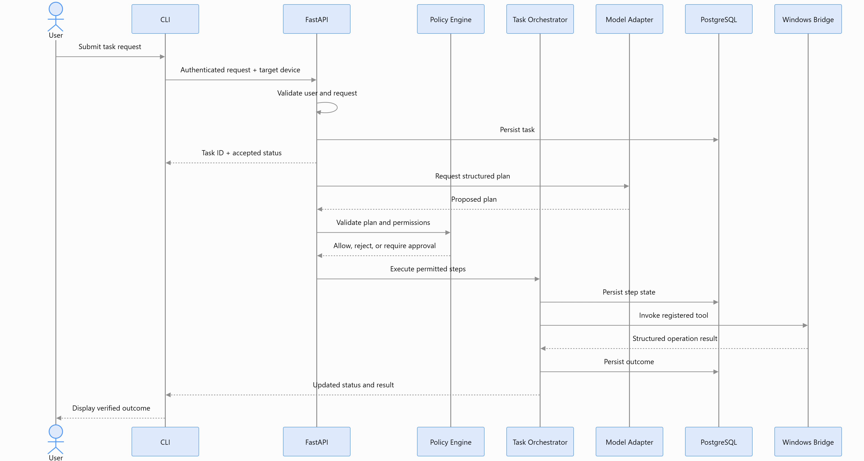

Important design note: This is a logical interaction sequence, not a commitment that every operation will execute synchronously inside one HTTP request. Long-running work should use a durable task lifecycle, with clients able to retrieve progress separately. The API and execution mechanics will be specified in later sections.

3.5 Proposed deployment boundary
We know each user needs a bridge on their own Windows computer. We do not yet know where the shared services will run.
Two plausible topologies remain:

Option A — One designated team computer
Fastest initial setup if the machine is available and has sufficient resources. It hosts the backend, database and potentially the model runtime; teammates connect over the LAN.

Option B — Separate always-on machine
Provides a dedicated service host and reduces dependence on a developer laptop being online, but requires another suitable machine and additional deployment work.
Both options must preserve the per-user Windows bridge boundary. Running the backend on one computer does not mean that all computer operations should run on that host.

3.6 Decisions deliberately deferred
We should not lock these before the next design stages:
- The physical host and service topology.
- The exact local model and whether inference is shared.
- The transport and authentication mechanism between backend and bridge.
- Whether a durable queue is needed or whether PostgreSQL-backed task coordination is sufficient.
- The detailed database schema and transaction boundaries.
- The exact task state machine and legal transitions.
- The approval expiry, timeout and retry defaults.
- The numerical latency and concurrency targets.
These are not forgotten requirements. They are tracked architecture decisions that need evidence or a more detailed design.

